Problem Statement: Air Pollution–Weather Coupled Forecasting System (Delhi NCR Focus)

Description
Traditional Air Quality Index (AQI) forecasting models typically treat meteorology and pollution dispersion as separate entities. However, in highly polluted urban landscapes like Delhi NCR, there is a critical, dynamic feedback loop between the weather and pollutants. During peak pollution seasons (such as the winter stubble-burning period), atmospheric inversion layers trap particulate matter close to the ground. Conversely, dense concentrations of aerosols (PM2.5) block sunlight,altering local temperatures, wind patterns, and planetary boundary layer (PBL) heights. Ignoring these coupled meteorological-chemical feedback loops leads to significant inaccuracies in standard AQI predictions. To achieve high-accuracy, actionable insights, there is an urgent need for an integrated system that simulates real-time interactions between atmospheric physics and chemical transport.
The challenge is to build a high-resolution, coupled forecasting system specifically tailored for Delhi NCR that predicts AQI for the next 72 hours.
The solution must leverage advanced weather-chemistry models (such as WRF-Chem or similar open-source coupled frameworks) to dynamically interlink meteorology with pollution dispersion(specifically PM2.5 and Ground-level Ozone). A core focus should be accurately modelling the impact of atmospheric inversion on external pollution spikes, such as regional stubble burning, and how those trapped pollutants subsequently alter local weather conditions. Implement a workflow that handles two-way feedback between meteorology (temperature, wind, PBL height) and chemistry (PM2.5, PM10, O3,NOx). A user-friendly, real-time dashboard displaying high-resolution AQI forecasts for Delhi NCR with a 72-hour outlook. Features that explicitly track atmospheric inversion strength and predict how stubble-burning plumes will disperse under prevailing weather conditions.

1. Background
- Traditional Air Quality Index (AQI) forecasting generally treats weather conditions and pollution dispersion as separate processes.
- In highly polluted regions like Delhi NCR, weather and air pollution are strongly interconnected.
- During winter, atmospheric inversion layers can trap pollutants such as PM2.5 near the ground, causing AQI to deteriorate rapidly.
- At the same time, high concentrations of aerosols/PM2.5 reduce sunlight, which can affect:
  - Temperature
  - Wind patterns
  - Planetary Boundary Layer (PBL) height
- Therefore, weather influences pollution, while pollution can also influence local weather.
- Accurate AQI prediction requires modelling this two-way interaction between atmospheric conditions and pollutants.
2. Problem
- Conventional AQI models may produce inaccurate predictions because they do not adequately consider the coupled relationship between meteorology and atmospheric chemistry.
- Delhi NCR experiences severe pollution episodes, particularly during the winter stubble-burning season.
- Atmospheric inversion can trap pollution close to the surface and significantly increase PM2.5 concentrations.
- Regional pollution sources such as stubble-burning emissions can travel into Delhi NCR depending on wind and atmospheric conditions.
- Pollutants trapped in the atmosphere can subsequently influence:
  - Temperature, Wind
  - PBL height
  - Atmospheric conditions
- The challenge is therefore to accurately predict these dynamic weather–pollution interactions and forecast AQI for the next 72 hours.
3. Proposed Solution
- Develop a high-resolution, coupled weather–chemistry forecasting system specifically for Delhi NCR.
- Use advanced open-source coupled atmospheric models such as WRF-Chem or similar frameworks.
- Integrate:
  - Meteorological data: Temperature, wind, PBL height, etc.
  - Chemical/pollution data: PM2.5, PM10, O₃, NOx, etc.
- Implement two-way feedback between weather and pollution.
- Accurately model how atmospheric inversions trap pollutants near the ground.
- Model the movement and dispersion of stubble-burning pollution plumes under changing wind and weather conditions.
- Simulate how accumulated pollutants can subsequently affect local meteorological conditions.
- Generate a 72-hour AQI forecast for Delhi NCR.
- Provide a user-friendly real-time dashboard showing:
  - AQI forecast
  - Pollution levels
  - Atmospheric inversion strength
  - Stubble-burning plume movement
  - Weather conditions
Simple Architecture
Weather + Pollution Data → Coupled Weather-Chemistry Model → Two-Way Weather ↔ Pollution Interaction → PM2.5/O₃ Forecast → AQI Prediction → 72-Hour Delhi NCR Dashboard

4. Mandatory Functional Scope
A. Coupled Weather–Chemistry Model
- Implement WRF-Chem or an equivalent open-source coupled framework.
- Dynamically connect atmospheric meteorology with chemical transport.
- Support two-way interaction between:
  - Meteorology: Temperature, wind, PBL height
  - Chemistry: PM2.5, PM10, O₃, NOx
B. 72-Hour AQI Forecast
- Generate high-resolution AQI predictions for Delhi NCR.
- Provide forecasts for the next 72 hours.
- Predict important pollutants, especially:
  - PM2.5
  - Ground-level Ozone (O₃)
C. Atmospheric Inversion Detection
- Detect and track the strength of atmospheric inversion layers.
- Determine how inversion conditions affect pollutant accumulation near the ground.
- Incorporate inversion effects into AQI predictions.
D. Stubble-Burning Plume Tracking
- Model pollution originating from regional stubble burning.
- Predict how the pollution plume will:
  - Travel
  - Disperse
  - Accumulate
  - Enter Delhi NCR
- Consider prevailing wind and atmospheric conditions.
E. Two-Way Feedback Modelling
The system must capture:
Weather → Pollution
- Wind → pollutant dispersion
- Temperature/inversion → pollutant trapping
- PBL height → pollutant concentration
And:
Pollution → Weather
- Aerosols → reduced sunlight
- PM2.5 → temperature changes
- Pollution → changes in local atmospheric conditions/PBL
F. Real-Time Dashboard
Provide a user-friendly dashboard displaying:
- Current AQI
- 72-hour AQI forecast
- PM2.5/PM10 levels
- O₃ and NOx levels
- Temperature
- Wind conditions
- PBL height
- Atmospheric inversion strength
- Stubble-burning plume movement and dispersion

In one line:
The project aims to build a high-resolution Delhi NCR AQI forecasting system that couples weather and atmospheric chemistry using models such as WRF-Chem, captures the two-way interaction between meteorology and pollutants, predicts stubble-burning pollution and inversion effects, and provides actionable 72-hour AQI forecasts through a real-time dashboard.
RELATION BETWEEN SIH PS & ISRO PS
1. Core Difference Between the Two
ISRO / Bharat Antariksh Hackathon
The main question is:
"What is happening, where is it happening, and where are the pollution sources?"
It uses satellite + ground + meteorological + fire data to:
- Generate surface AQI maps across India.
- Estimate surface pollutant concentrations from satellite observations.
- Detect HCHO hotspots.
- Identify major pollution/source regions.
- Analyze the relationship between biomass burning and HCHO.
- Study how pollutants are transported using wind/reanalysis data.
So, ISRO is primarily an observation + estimation + source identification + spatial analysis problem.

Smart India Hackathon
The main question is:
"Given the current atmospheric and pollution conditions, what will happen during the next 72 hours?"
It focuses specifically on Delhi NCR and requires:
- Weather–chemistry coupling.
- PM2.5, PM10, O₃ and NOx modelling.
- Atmospheric inversion modelling.
- Stubble-burning plume dispersion.
- Two-way interaction between weather and pollution.
- 72-hour AQI forecasting.
- Real-time visualization/dashboard.
So, SIH is primarily a forecasting + simulation + prediction problem.

2. Are They Interrelated?
YES — Very Strongly.
Think of the two systems like this:
ISRO
Satellite observes the atmosphere
⬇️
Pollution + HCHO + fire hotspots + meteorology
⬇️
Where pollution is coming from / where it is now

SIH
Current atmospheric state + emission sources
⬇️
Weather–chemistry coupled model
⬇️
How pollution will move and evolve
⬇️
72-hour AQI forecast

So essentially:
ISRO = Observation & Source Intelligence
SIH = Prediction & Future-State Intelligence
That is a very strong relationship.

3. Where Exactly Do They Overlap?
There are 5 major connection points.
A. Stubble Burning 🔥
This is probably the strongest connection.
The ISRO problem specifically asks for:
- Biomass-burning periods
- HCHO hotspots
- Major source regions
- Relationship between fire activity and HCHO
- Transport influence using wind data.
The SIH problem specifically asks for:
- Modelling regional stubble-burning pollution.
- Predicting plume movement.
- Predicting how the plume enters Delhi NCR.
- Understanding how weather affects plume dispersion.
Connection:
ISRO detects the source → SIH predicts where that source's pollution will go.
For example:
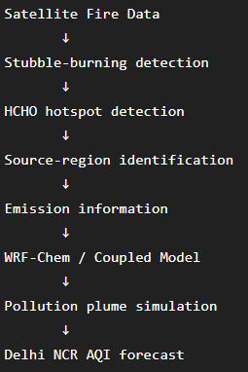
4. HCHO Is Also Useful
This is another interesting connection.
The ISRO problem focuses heavily on HCHO (formaldehyde) because it is an indicator of VOC emissions and plays an important role in atmospheric chemistry and ozone formation. The problem statement specifically connects enhanced HCHO with biomass-burning events.
SIH, meanwhile, requires modelling:
- PM2.5
- PM10
- O₃
- NOx
and atmospheric chemistry.
So HCHO isn't explicitly listed as a primary SIH forecast variable, but it can provide valuable chemical/source information, particularly for understanding biomass burning and ozone-related chemistry.
In other words:
HCHO → VOC/source indicator → atmospheric chemistry → O₃ formation
This could potentially strengthen the SIH model.

5. Meteorology Is Another Common Layer 🌦️
Both problems use meteorological information.
ISRO
Uses:
- ERA5
- IMDAA
- MERRA-2
for meteorological parameters and pollutant transport analysis.

SIH
Explicitly models:
- Temperature
- Wind
- PBL height
- Atmospheric inversion
and their interactions with pollution.
Therefore:
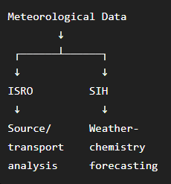
6. The Biggest Difference: Static/Current vs Future
This is important if you're thinking about using both problems together.
ISRO
Primarily produces:
"Current/recent spatial understanding."
For example:
"This region has high HCHO concentration."
"These areas show biomass-burning activity."
"These are major pollution source regions."
"Pollution is being transported in this direction."
The ISRO workflow uses satellite, CPCB, fire and meteorological data and applies deep learning to estimate surface concentrations and create AQI maps.

SIH
Produces:
"Future prediction."
For example:
"Given today's atmospheric conditions, Delhi NCR AQI will reach X after 24 hours."
"This stubble-burning plume is likely to reach Delhi NCR."
"Strong inversion conditions will trap pollutants."
"PM2.5 will remain elevated for the next 72 hours."
The SIH requirement explicitly targets a 72-hour high-resolution forecast.

7. How We Could Combine Them
This is where it gets really interesting.
You could design a larger architecture:
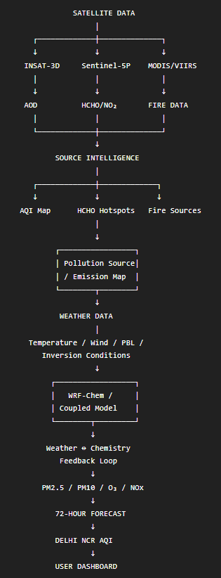

8. What ISRO Can Give to SIH
ISRO Output | Possible SIH Use
INSAT-3D AOD | PM2.5 estimation/initialization
Sentinel-5P HCHO | Biomass/VOC information
Sentinel-5P NO₂ | Chemical/emission information
Sentinel-5P O₃ | Atmospheric chemistry information
MODIS/VIIRS fire counts | Stubble-burning source identification
HCHO hotspots | Identify potential emission regions
Source-region analysis | Emission/input information
Wind/reanalysis data | Pollution transport
Satellite AQI maps | Model validation/calibration
CPCB measurements | Ground-truth/validation

The ISRO problem itself requires integration of satellite, CPCB, fire-count and reanalysis datasets.

9. What SIH Adds That ISRO Doesn't
SIH brings the actual forecasting engine.
The major additions are:
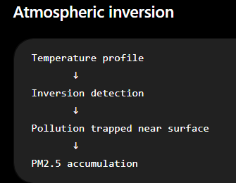
SIH explicitly requires tracking inversion strength and incorporating its effect into AQI prediction.
TWO-WAY FEEDBACK
Unlike simply correlating satellite observations with pollution, SIH requires:
Weather
↓
Pollution dispersion

Pollution
↓
Atmospheric changes
The SIH document explicitly requires this two-way weather–pollution interaction.

10. So Are They the Same Project?
❌ No.
You should not present them as identical.
Their primary objectives are different:
Aspect | ISRO Hackathon | SIH
Primary goal | Satellite-based AQI & HCHO analysis | 72-hour AQI forecasting
Geographic scope | India | Delhi NCR
Main data | Satellite + CPCB + fire + met | Weather + chemistry + emissions
Main technology | Remote sensing + DL | WRF-Chem/coupled modelling
HCHO | Major focus | Supporting chemical information
Stubble burning | Source identification | Plume forecasting
AQI | Spatial estimation/mapping | Future prediction
Weather | Transport/context | Core coupled variable
Forecast horizon | Not the main focus | 72 hours
Main output | AQI/HCHO maps + hotspots | AQI forecast + plume/inversion dashboard

11. But They Can Form One Powerful Pipeline
This is the key takeaway.
You could think of them as:
🛰️ ISRO Layer
"Observe Earth"
↓
🧠 AI/Remote Sensing Layer
"Understand what is happening"
↓
🌦️ Weather-Chemistry Layer
"Understand why it is happening"
↓
🔮 Forecasting Layer
"Predict what happens next"
↓
📊 Decision Support Layer
"Tell authorities what to do"
That would create a much more sophisticated system than either problem individually.

12. IF YOU'RE CHOOSING BETWEEN THEM
If your question is actually:
"Which one should we choose for our project/hackathon?"
Then I'd look at it differently.
ISRO PROBLEM IS STRONGER IF YOU WANT:
- Satellite/remote sensing
- AI/ML
- Computer vision/geospatial AI
- Google Earth Engine
- Deep learning
- Satellite data analysis
- Pan-India application
- HCHO/fire hotspot detection
The ISRO document even suggests CNN, LSTM and CNN-LSTM approaches and evaluates RMSE, R, MAE, hotspot detection, multi-source integration and visualization.
SIH problem is stronger if you want:
- Atmospheric modelling
- Weather + pollution interaction
- WRF-Chem
- Numerical modelling
- Forecasting
- Stubble-burning plume prediction
- Delhi NCR-specific impact
- 72-hour prediction
- Real-time dashboard

🚀 My Overall Assessment
I’d rate their relationship like this:
Relationship | Strength
Common pollution/AQI objective | ⭐⭐⭐⭐⭐
Common meteorological data | ⭐⭐⭐⭐⭐
Stubble-burning connection | ⭐⭐⭐⭐⭐
Satellite-data connection | ⭐⭐⭐⭐⭐
HCHO ↔ atmospheric chemistry | ⭐⭐⭐⭐
Direct model compatibility | ⭐⭐⭐⭐
Same final objective | ⭐⭐
Complementary nature | ⭐⭐⭐⭐⭐
Overall interrelation: ~85–90%
But they solve different stages of the larger problem.
ISRO tells you where pollution is, where it is coming from, and provides satellite-derived observations. SIH takes atmospheric conditions and pollution sources and predicts how the pollution will evolve over the next 72 hours.
And bro, this is actually a very interesting opportunity: if you’re considering building a project that can satisfy the core requirements of both, we could design a single integrated architecture where the ISRO satellite-AQI/HCHO module becomes the observation/data-assimilation layer and the SIH WRF-Chem module becomes the forecasting layer. That would be a genuinely strong technical story rather than simply combining two unrelated ideas.

ALRIGHT CAN WE COMBINE BOTH THE PROJECTS FOR SIH 2026 WHICH WILL ALSO PROVIDE THE NOVELTY AND UNIQUENESS TO OUR PROJECT
Absolutely bro. Yes — we can combine both, and I actually think this can make your SIH 2026 solution considerably stronger if we integrate them properly rather than simply putting two projects together.
The key is:
SIH problem = forecasting engine
ISRO problem = satellite-based observation, source identification and data-assimilation layer
The SIH statement requires a high-resolution Delhi NCR system with two-way weather–chemistry coupling, 72-hour AQI prediction, inversion tracking and stubble-burning plume prediction.
The ISRO statement provides satellite-derived AQI/HCHO analysis, biomass-burning hotspot identification, source-region identification and transport analysis using satellite, fire and meteorological datasets.
So we can build one unified system around them.

🚀 THE COMBINED IDEA
I'd position the project as something like:
"Satellite-Assisted AI Digital Twin for 72-Hour Air Pollution Forecasting in Delhi NCR"
Or a more competition-friendly name:
AeroSense-Delhi
AI + Satellite + Weather-Chemistry Coupled AQI Intelligence Platform
The core concept:
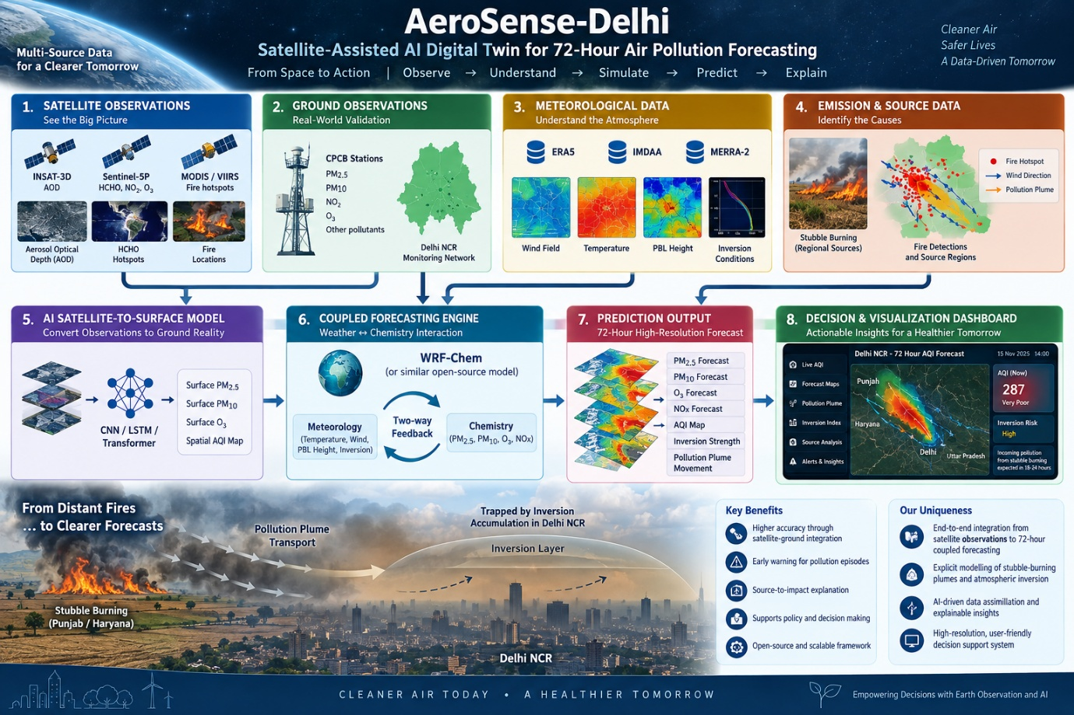
This isn't just "two projects combined."
It's a multi-layer pollution intelligence system.

1. WHAT WE TAKE FROM THE ISRO PROBLEM
The ISRO problem gives us the Earth-observation intelligence layer.
Its required datasets include:
- INSAT-3D AOD
- Sentinel-5P/TROPOMI
- CPCB ground observations
- MODIS/VIIRS fire data
- ERA5/IMDAA/MERRA-2 meteorological data.
We can use these to answer:
"WHAT IS HAPPENING RIGHT NOW?"
For example:
Satellite → AOD → estimated PM2.5
Satellite → HCHO → VOC/biomass-burning indicator
MODIS/VIIRS → fire locations → stubble-burning source
Wind → source-to-Delhi transport direction
This is directly supported by the ISRO problem's objectives and expected outcomes.

2. THEN SIH TAKES OVER
Once we have this information, we feed it into the SIH forecasting system.
SIH specifically requires the system to model:
- PM2.5
- PM10
- O₃
- NOx
- Temperature
- Wind
- PBL height
- Atmospheric inversion
- Stubble-burning plume movement
- Two-way weather–chemistry interaction.
So our system doesn't just say:
"Delhi AQI is 350."
Instead, it can say something much more useful:
AQI is expected to increase significantly in the next 18–24 hours because a detected biomass-burning plume is moving toward Delhi under weak winds and strong atmospheric inversion conditions.
That's a much stronger decision-support story.

3. THE NOVELTY 🔥
This is where I think your project can become interesting.
The individual technologies aren't necessarily novel by themselves.
We should not claim:
"We invented WRF-Chem."
or
"We invented satellite-based AQI."
Instead, our novelty should be in the integration and intelligence layer.
OUR NOVELTY:
SATELLITE → SOURCE → ATMOSPHERE → CHEMISTRY → FORECAST → EXPLANATION
Most importantly, we can create a closed-loop system.

4. NOVEL FEATURE #1 — SATELLITE-ASSISTED FORECAST INITIALIZATION
This could be one of our strongest ideas.
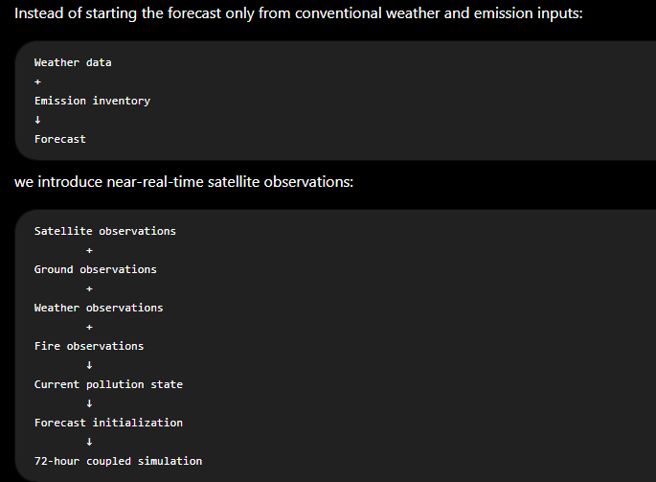The
ISRO problem already expects satellite-derived pollutant information to be compared with CPCB ground observations.
So we can use this as our observation/data-assimilation concept.

5. NOVEL FEATURE #2 — STUBBLE-BURNING SOURCE INTELLIGENCE
This can become a very cool module.
Instead of simply using a predefined stubble-burning emission map:
Our system detects:
Where are the fires?
↓
How strong are the HCHO hotspots?
↓
What direction is the wind moving?
↓
Is the atmosphere trapping pollution?
↓
Will the plume reach Delhi?
↓
When will it arrive?
↓
How much could it affect PM2.5/AQI?
That combines the two problem statements extremely naturally.

6. NOVEL FEATURE #3 — POLLUTION "CAUSE → EFFECT" EXPLANATION
This is something I'd strongly recommend.
Don't make the dashboard only show numbers.
Instead, provide an AI-generated pollution explanation.
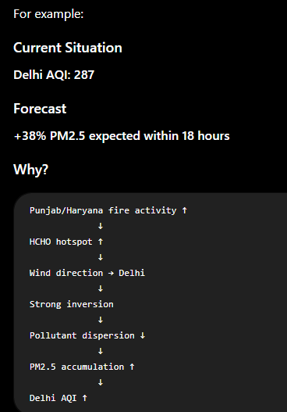
This converts a complicated scientific model into something an authority can understand.
7. NOVEL FEATURE #4 — ATMOSPHERIC INVERSION RISK INDEX
SIH explicitly requires atmospheric inversion tracking.
We could turn it into a simple indicator:
Inversion Risk
🟢 Low
🟡 Moderate
🟠 High
🔴 Severe
And combine it with incoming pollution:
Inversion Strength
+
Incoming Pollution
+
Wind Speed
+
PBL Height
↓
Pollution Accumulation Risk
So instead of simply forecasting AQI, the system predicts pollution accumulation risk.

8. NOVEL FEATURE #5 — POLLUTION PLUME DIGITAL MAP
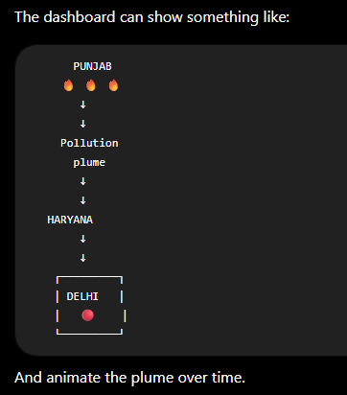

Slider:
Now → +6h → +12h → +24h → +48h → +72h
The user can visually see:
"Where will the pollution go?"
That would make the demo much more impressive.

9. OUR COMPLETE ARCHITECTURE
I would divide the system into 6 major modules.
MODULE 1 — EARTH OBSERVATION ENGINE
Inputs:
- INSAT-3D
- Sentinel-5P
- MODIS/VIIRS
Outputs:
- AOD
- HCHO
- NO₂
- O₃
- Fire locations
- Satellite-derived pollution indicators

MODULE 2 — GROUND TRUTH ENGINE
Inputs:
- CPCB stations
Outputs:
- PM2.5
- PM10
- NO₂
- O₃ etc.
The ISRO statement explicitly requires CPCB data for surface pollutant modelling and validation.

MODULE 3 — METEOROLOGICAL ENGINE
Inputs:
- ERA5
- IMDAA
- MERRA-2
Outputs:
- Temperature
- Wind speed/direction
- PBL height
- Atmospheric stability
- Inversion conditions

MODULE 4 — AI SATELLITE-TO-SURFACE MODEL
This is where your AI/ML comes in.
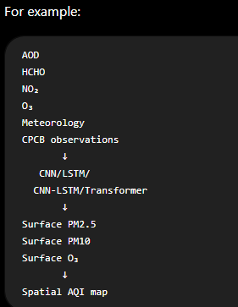
This follows the ISRO problem's suggested CNN/LSTM/CNN-LSTM approach.

MODULE 5 — COUPLED FORECASTING ENGINE
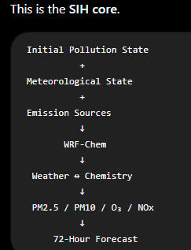
SIH specifically requires this two-way interaction.

MODULE 6 — AI DECISION & VISUALIZATION LAYER
This is where we make the project competition-ready.
Display:
- Current AQI
- 72-hour AQI
- PM2.5
- PM10
- O₃
- NOx
- Inversion strength
- Fire hotspots
- HCHO hotspots
- Pollution sources
- Plume trajectory
- Expected arrival time
- Pollution risk
- Confidence level
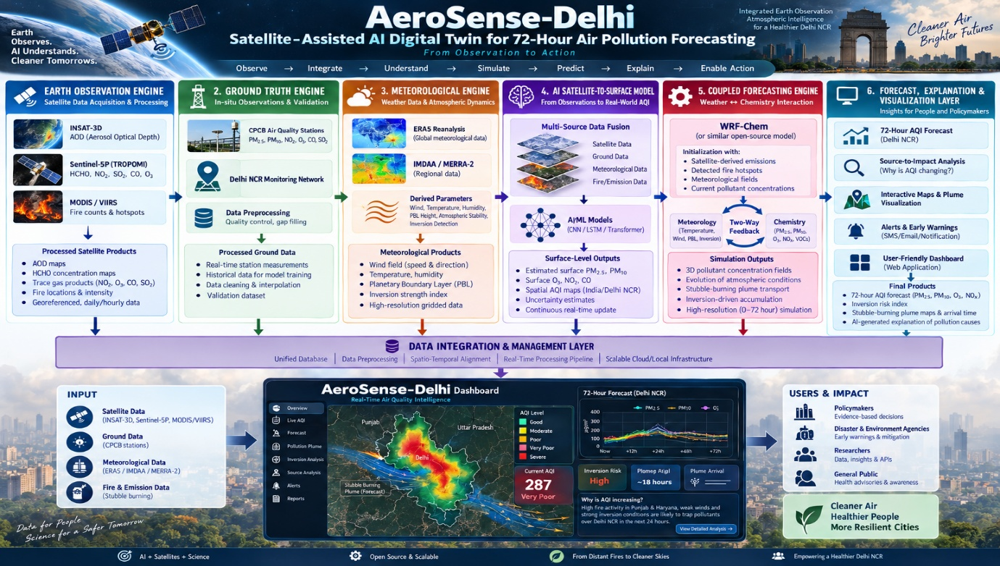

10. WHAT MAKES THIS DIFFERENT FROM SIMPLY COMBINING THEM?
This distinction is very important for your SIH presentation.
Don't tell the judges:
"We combined the ISRO problem with the SIH problem."
❌ That's not a novelty claim.
Instead say:
"We propose a satellite-assisted, observation-to-forecast framework that assimilates multi-source Earth-observation and ground measurements into a coupled meteorological–chemical forecasting system to improve 72-hour AQI prediction and explain pollution source-to-impact pathways."

11. One Major Caution ⚠️
We need to keep SIH's original mandatory requirements at the center.
The SIH statement is specifically asking for a Delhi NCR 72-hour coupled forecasting system.
So don't make the project:
"India-wide satellite AQI mapping with a little Delhi forecasting."
That could weaken your alignment with the SIH problem.
Instead:
Core SIH
Delhi NCR 72-hour coupled forecast
Supporting innovation
Satellite-based observation + source intelligence
Additional value
Explainable pollution-source → plume → AQI pathway

12. THE FINAL PROJECT STORY
Your project story becomes extremely clean:
STEP 1 — OBSERVE
🛰️ Satellites detect:
- Aerosols
- HCHO
- NO₂
- O₃
- Fire activity
STEP 2 — UNDERSTAND
AI combines:
- Satellite data
- CPCB
- Meteorology
- Fire data
to estimate the current pollution state.
STEP 3 — Identify Source
AI identifies:
Where is the pollution coming from?
STEP 4 — Simulate
WRF-Chem/coupled model determines:
How will weather transport the pollution?
STEP 5 — Feedback
The model calculates:
How will pollution itself alter atmospheric conditions?
STEP 6 — Forecast
Generate:
0–72 hours AQI forecast
STEP 7 — Explain
Tell the user:
Why will AQI increase?
STEP 8 — Visualize
Show:
Source → Plume → Delhi → AQI

🏆 And This Gives You a Strong USP
I'd summarize your USP as:
"From observing pollution to explaining its source to forecasting its future impact."
Or even shorter for your pitch:
"Observe → Understand → Simulate → Predict → Explain."
That is much more compelling than simply saying "AI-based AQI forecasting."

My recommendation
Yes, combine them. But architect the project as a SIH-first solution with an ISRO-derived satellite intelligence layer, not as two separate solutions glued together.
And there's another important advantage: the ISRO problem already gives you a very strong data/AI foundation—INSAT-3D, Sentinel-5P, CPCB, MODIS/VIIRS and reanalysis datasets—while SIH gives you the much more ambitious forecasting objective.
If we execute this properly, your final system could look like:
🛰️ Satellite Observation + 🔥 Source Detection + 🤖 AI Surface AQI + 🌦️ Weather Model + 🧪 WRF-Chem + 🧠 AI/Data Assimilation + 🔮 72h Forecast + 🗺️ Interactive Pollution Digital Twin
That's a much stronger SIH project concept than either problem statement taken alone.
If you're serious about taking this forward, the next step should be to design the actual SIH architecture — including which modules we build ourselves, which open-source models we use, datasets, AI models, WRF-Chem role, training pipeline, dashboard, novelty claims, and a realistic MVP that your team can actually finish before the SIH evaluation.

